Last updated 1/13/2026
1. Groundwater levels reported as daily averages for the continuously monitored network - CMN.
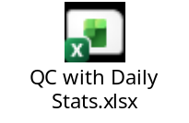
2. Groundwater levels for the CMN all data with 30-minute frequency.
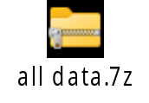
3. Groundwater levels for the bi-annual static water level (SWL) synoptics.
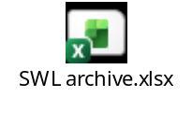
4. Well information
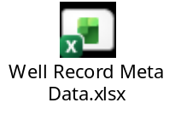

5. Water Quality
